MVC:

By reading these MVC interview question it does not mean you will go and clear MVC interviews. The whole purpose of this article is to quickly brush up your MVC knowledge before you for the MVC interviews.

This article does not teach MVC, it’s a last minute revision sheet before going for MVC interviews.

In case you want to learn MVC from scratch start by reading [Learn MVC ( Model view controller) step by step 7 days](http://www.codeproject.com/Articles/207797/Learn-MVC-Model-View-Controller-step-by-step-in-7) or you can also start with my [step by step MVC ( Model view controller) video series from youtube.](https://www.youtube.com/playlist?list=PL33C9E91F8CDD2BF7)

**What is MVC(Model view controller)?**

MVC is architectural pattern which separates the representation and the user interaction. It’s divided in three broader sections, “Model”, “View” and “Controller”. Below is how each one of them handles the task.

* The “View” is responsible for look and feel.
* “Model” represents the real world object and provides data to the “View”.
* The “Controller” is responsible to take the end user request and load the appropriate “Model” and “View”.

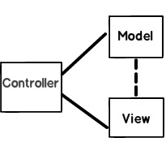

**Figure: - MVC (Model view controller)**

**Can you explain the complete flow of MVC?**

Below are the steps how control flows in MVC (Model, view and controller) architecture:-

* All end user requests are first sent to the controller.
* The controller depending on the request decides which model to load. The controller loads the model and attaches the model with the appropriate view.
* The final view is then attached with the model data and sent as a response to the end user on the browser.

**Is MVC suitable for both windows and web application?**

MVC architecture is suited for web application than windows. For window application MVP i.e. “Model view presenter” is more applicable.IfyouareusingWPFandSLMVVMismoresuitableduetobindings.

**What are the benefits of using MVC?**

There are two big benefits of MVC:-

Separation of concerns is achieved as we are moving the code behind to a separate class file. By moving the binding code to a separate class file we can reuse the code to a great extent.

Automated UI testing is possible because now the behind code (UI interaction code) has moved to a simple.NET class. This gives us opportunity to write unit tests and automate manual testing.

**Is MVC different from a 3 layered architecture?**

MVC is an evolution of a 3 layered traditional architecture. Many components of 3 layered architecture are part of MVC.  So below is how the mapping goes.

|  |  |  |
| --- | --- | --- |
| **Functionality** | **3 layered / tiered architecture** | **Model view controller architecture** |
| Look and Feel | User interface. | View. |
| UI logic | User interface. | Controller |
| Business logic /validations | Middle layer | Model. |
| Request is first sent to | User interface | Controller. |
| Accessing data | Data access layer. | Data access layer. |

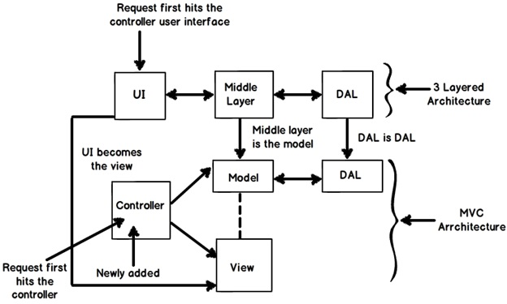

**Figure: - 3 layered architecture**

**What is the latest version of MVC?**

When this note was written, four versions where released of MVC. MVC 1 , MVC 2, MVC 3 and MVC 4. So the latest is MVC 4.

**What is the difference between each version of MVC?**

Below is a detail table of differences. But during interview it’s difficult to talk about all of them due to time limitation. So I have highlighted important differences which you can run through before the interviewer.

|  |  |  |
| --- | --- | --- |
| **MVC 2** | **MVC 3** | **MVC 4** |
| **Client-Side Validation Templated Helpers Areas Asynchronous Controllers** Html.ValidationSummary Helper Method DefaultValueAttribute in Action-Method Parameters Binding Binary Data with Model Binders DataAnnotations Attributes Model-Validator Providers New RequireHttpsAttribute Action Filter Templated Helpers Display Model-Level Errors | **Razor**  Readymade project templates  **HTML 5 enabled templatesSupport for Multiple View EnginesJavaScript and Ajax**  Model Validation Improvements | **ASP.NET Web API**  Refreshed and modernized default project templatesNew mobile project template  **Many new features to support mobile apps**  Enhanced support for asynchronous methods |

**What are routing in MVC?**

Routing helps you to define a URL structure and map the URL with the controller.

For instance let’s say we want that when any user types “<http://localhost/View/ViewCustomer/>”,  it goes to the  “Customer” Controller  and invokes “DisplayCustomer” action.  This is defined by adding an entry in to the “routes” collection using the “maproute” function. Below is the under lined code which shows how the URL structure and mapping with controller and action is defined.

http://www.codeproject.com/images/minus.gifCollapse | [Copy Code](http://www.codeproject.com/Articles/556995/Model-view-controller-MVC-Interview-questions-and)

routes.MapRoute(

"View", // Route name

"View/ViewCustomer/{id}", // URL with parameters

new { controller = "Customer", action = "DisplayCustomer",

id = UrlParameter.Optional }); // Parameter defaults

**Where is the route mapping code written?**

The route mapping code is written in the “global.asax” file.

**Can we map multiple URL’s to the same action?**

Yes , you can , you just need to make two entries with different key names and specify the same controller and action.

**How can we navigate from one view to other view using hyperlink?**

By using “ActionLink” method as shown in the below code. The below code will create a simple URL which help to navigate to the “Home” controller and invoke the “GotoHome” action.

http://www.codeproject.com/images/minus.gifCollapse | [Copy Code](http://www.codeproject.com/Articles/556995/Model-view-controller-MVC-Interview-questions-and)

<%= Html.ActionLink("Home","Gotohome") %>

**How can we restrict MVC actions to be invoked only by GET or POST?**

We can decorate the MVC action by “HttpGet” or “HttpPost” attribute to restrict the type of HTTP calls. For instance you can see in the below code snippet the “DisplayCustomer” action can only be invoked by “HttpGet”. If we try to make Http post on “DisplayCustomer” it will throw an error.

http://www.codeproject.com/images/minus.gifCollapse | [Copy Code](http://www.codeproject.com/Articles/556995/Model-view-controller-MVC-Interview-questions-and)

[HttpGet]

public ViewResult DisplayCustomer(int id)

{

Customer objCustomer = Customers[id];

return View("DisplayCustomer",objCustomer);

}

**How can we maintain session in MVC?**

Sessions can be maintained in MVC by 3 ways tempdata ,viewdata and viewbag.

**What is the difference between tempdata ,viewdata and viewbag?**

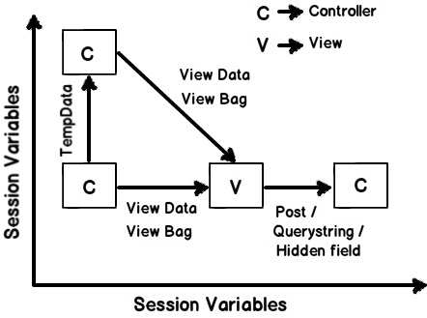

**Figure:- difference between tempdata , viewdata and viewbag**

**Temp data: -**Helps to maintain data when you move from one controller to other controller or from one action to other action. In other words when you redirect,“tempdata” helps to maintain data between those redirects. It internally uses session variables.

**View data: -** Helps to maintain data when you move from controller to view.

**View Bag: -** It’s a dynamic wrapper around view data. When you use “Viewbag” type casting is not required. It uses the dynamic keyword internally.

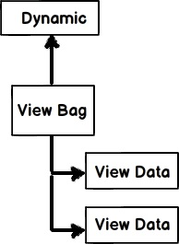

**Figure:-dynamic keyword**

**Session variables: -** By using session variables we can maintain data from any entity to any entity.

**Hidden fields and HTML controls: -** Helps to maintain data from UI to controller only. So you can send data from HTML controls or hidden fields to the controller using POST or GET HTTP methods.

Below is a summary table which shows different mechanism of persistence.

|  |  |  |  |  |
| --- | --- | --- | --- | --- |
| **Maintains data between** | **ViewData/ViewBag** | **TempData** | **Hidden fields** | **Session** |
| **Controller to Controller** | No | Yes | No | Yes |
| **Controller to View** | Yes | No | No | Yes |
| **View to Controller** | No | No | Yes | Yes |

**What are partial views in MVC?**

Partial view is a reusable view (like a user control) which can be embedded inside other view. For example let’s say all your pages of your site have a standard structure with left menu, header and footer as shown in the image below.

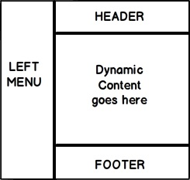

**Figure:- partial views in MVC**

For every page you would like to reuse the left menu, header and footer controls. So you can go and create partial views for each of these items and then you call that partial view in  the  main view.

**How did you create partial view and consume the same?**

When you add a view to your project you need to check the “Create partial view” check box.

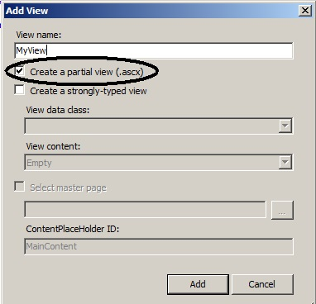

**Figure:-createpartialview**

Once the partial view is created you can then call the partial view in the main view using “Html.RenderPartial” method as shown in the below code snippet.

http://www.codeproject.com/images/minus.gifCollapse | [Copy Code](http://www.codeproject.com/Articles/556995/Model-view-controller-MVC-Interview-questions-and)

<body>

<div>

<% Html.RenderPartial("MyView"); %>

</div>

</body>

**How can we do validations in MVC?**

One of the easy ways of doing validation in MVC is by using data annotations. Data annotations are nothing but attributes which you can be applied on the model properties. For example in the below code snippet we have a simple “customer” class with a property “customercode”.

This”CustomerCode” property is tagged with a “Required” data annotation attribute. In other words if this model is not provided customer code it will not accept the same.

http://www.codeproject.com/images/minus.gifCollapse | [Copy Code](http://www.codeproject.com/Articles/556995/Model-view-controller-MVC-Interview-questions-and)

public class Customer

{

[Required(ErrorMessage="Customer code is required")]

public string CustomerCode

{

set;

get;

}

}

In order to display the validation error message we need to use “ValidateMessageFor” method which belongs to the “Html” helper class.

http://www.codeproject.com/images/minus.gifCollapse | [Copy Code](http://www.codeproject.com/Articles/556995/Model-view-controller-MVC-Interview-questions-and)

<% using (Html.BeginForm("PostCustomer", "Home", FormMethod.Post))

{ %>

<%=Html.TextBoxFor(m => m.CustomerCode)%>

<%=Html.ValidationMessageFor(m => m.CustomerCode)%>

<input type="submit" value="Submit customer data" />

<%}%>

Later in the controller we can check if the model is proper or not by using “ModelState.IsValid” property and accordingly we can take actions.

http://www.codeproject.com/images/minus.gifCollapse | [Copy Code](http://www.codeproject.com/Articles/556995/Model-view-controller-MVC-Interview-questions-and)

public ActionResult PostCustomer(Customer obj)

{

if (ModelState.IsValid)

{

obj.Save();

return View("Thanks");

}

else

{

return View("Customer");

}

}

Below is a simple view of how the error message is displayed on the view.

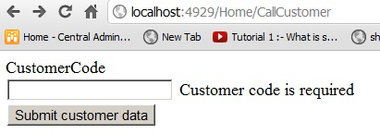

**Figure:- validations in MVC**

**Can we display all errors in one go?**

Yes we can, use “ValidationSummary” method from HTML helper class.

http://www.codeproject.com/images/minus.gifCollapse | [Copy Code](http://www.codeproject.com/Articles/556995/Model-view-controller-MVC-Interview-questions-and)

<%= Html.ValidationSummary() %>

What are the other data annotation attributes for validation in MVC?

If you want to check string length, you can use “StringLength”.

http://www.codeproject.com/images/minus.gifCollapse | [Copy Code](http://www.codeproject.com/Articles/556995/Model-view-controller-MVC-Interview-questions-and)

[StringLength(160)]

public string FirstName { get; set; }

In case you want to use regular expression, you can use “RegularExpression” attribute.

http://www.codeproject.com/images/minus.gifCollapse | [Copy Code](http://www.codeproject.com/Articles/556995/Model-view-controller-MVC-Interview-questions-and)

[RegularExpression(@"[A-Za-z0-9._%+-]+@[A-Za-z0-9.-]+\.[A-Za-z]{2,4}")]public string Email { get; set; }

If you want to check whether the numbers are in range, you can use the “Range” attribute.

http://www.codeproject.com/images/minus.gifCollapse | [Copy Code](http://www.codeproject.com/Articles/556995/Model-view-controller-MVC-Interview-questions-and)

[Range(10,25)]public int Age { get; set; }

Some time you would like to compare value of one field with other field, we can use the “Compare” attribute.

http://www.codeproject.com/images/minus.gifCollapse | [Copy Code](http://www.codeproject.com/Articles/556995/Model-view-controller-MVC-Interview-questions-and)

public string Password { get; set; }[Compare("Password")]public string ConfirmPass { get; set; }

In case you want to get a particular error message , you can use the “Errors” collection.

http://www.codeproject.com/images/minus.gifCollapse | [Copy Code](http://www.codeproject.com/Articles/556995/Model-view-controller-MVC-Interview-questions-and)

var ErrMessage = ModelState["Email"].Errors[0].ErrorMessage;

If you have created the model object yourself you can explicitly call “TryUpdateModel” in your controller to check if the object is valid or not.

http://www.codeproject.com/images/minus.gifCollapse | [Copy Code](http://www.codeproject.com/Articles/556995/Model-view-controller-MVC-Interview-questions-and)

TryUpdateModel(NewCustomer);

In case you want add errors in the controller you can use “AddModelError” function.

http://www.codeproject.com/images/minus.gifCollapse | [Copy Code](http://www.codeproject.com/Articles/556995/Model-view-controller-MVC-Interview-questions-and)

ModelState.AddModelError("FirstName", "This is my server-side error.");

**How can we enable data annotation validation on client side?**

It’s a two-step process first reference the necessary jquery files.

http://www.codeproject.com/images/minus.gifCollapse | [Copy Code](http://www.codeproject.com/Articles/556995/Model-view-controller-MVC-Interview-questions-and)

<script src="<%= Url.Content("~/Scripts/jquery-1.5.1.js") %>" type="text/javascript"></script>

<script src="<%= Url.Content("~/Scripts/jquery.validate.js") %>" type="text/javascript"></script>

<script src="<%= Url.Content("~/Scripts/jquery.validate.unobtrusive.js") %>" type="text/javascript"></script>

Second step is to call “EnableClientValidation” method.

http://www.codeproject.com/images/minus.gifCollapse | [Copy Code](http://www.codeproject.com/Articles/556995/Model-view-controller-MVC-Interview-questions-and)

<% Html.EnableClientValidation(); %>

**What is razor in MVC?**

It’s a light weight view engine. Till MVC we had only one view type i.e.ASPX, Razor was introduced in MVC 3.

**Why razor when we already had ASPX?**

Razor is clean, lightweight and syntaxes are easy as compared to ASPX. For example in ASPX to display simple time we need to write.

http://www.codeproject.com/images/minus.gifCollapse | [Copy Code](http://www.codeproject.com/Articles/556995/Model-view-controller-MVC-Interview-questions-and)

<%=DateTime.Now%>

In Razor it’s just one line of code.

http://www.codeproject.com/images/minus.gifCollapse | [Copy Code](http://www.codeproject.com/Articles/556995/Model-view-controller-MVC-Interview-questions-and)

@DateTime.Now

**So which is a better fit Razor or ASPX?**

As per Microsoft razor is more preferred because it’s light weight and has simple syntaxes.

**How can you do authentication and authorization in MVC?**

You can use windows or forms authentication for MVC.

**How to implement windows authentication for MVC?**

For windows authentication you need to go and modify the “web.config” file and set authentication mode to windows.

http://www.codeproject.com/images/minus.gifCollapse | [Copy Code](http://www.codeproject.com/Articles/556995/Model-view-controller-MVC-Interview-questions-and)

<authentication mode="Windows"/>

<authorization>

<deny users="?"/>

</authorization>

Then in the controller or on the action you can use the “Authorize” attribute which specifies which users have access to these controllers and actions. Below is the code snippet for the same. Now only  the users specified in the controller and action can access the same.

http://www.codeproject.com/images/minus.gifCollapse | [Copy Code](http://www.codeproject.com/Articles/556995/Model-view-controller-MVC-Interview-questions-and)

[Authorize(Users= @"WIN-3LI600MWLQN\Administrator")]

public class StartController : Controller

{

//

// GET: /Start/

[Authorize(Users = @"WIN-3LI600MWLQN\Administrator")]

public ActionResult Index()

{

return View("MyView");

}

}

**How do you implement forms authentication in MVC?**

Forms authentication is implemented the same way as we do in ASP.NET. So the first step is to set authentication mode equal to forms. The “loginUrl” points to a controller here rather than page.

http://www.codeproject.com/images/minus.gifCollapse | [Copy Code](http://www.codeproject.com/Articles/556995/Model-view-controller-MVC-Interview-questions-and)

<authentication mode="Forms">

<forms loginUrl="~/Home/Login" timeout="2880"/>

</authentication>

**How do you implement forms authentication in MVC?**

Forms authentication is implemented the same way as we do in ASP.NET. So the first step is to set authentication mode equal to forms. The “loginUrl” points to a controller here rather than page.

http://www.codeproject.com/images/minus.gifCollapse | [Copy Code](http://www.codeproject.com/Articles/556995/Model-view-controller-MVC-Interview-questions-and)

<authentication mode="Forms">

<forms loginUrl="~/Home/Login" timeout="2880"/>

</authentication>

We also need to create a controller where we will check the user is proper or not. If the user is proper we will set the cookie value.

http://www.codeproject.com/images/minus.gifCollapse | [Copy Code](http://www.codeproject.com/Articles/556995/Model-view-controller-MVC-Interview-questions-and)

public ActionResult Login()

{

if ((Request.Form["txtUserName"] == "Shiv") && (Request.Form["txtPassword"] == "Shiv@123"))

{

FormsAuthentication.SetAuthCookie("Shiv",true);

return View("About");

}

else

{

return View("Index");

}

}

All the other actions need to be attributed with “Authorize” attribute so that any unauthorized user if he makes a call to these controllers it will redirect to the controller ( in this case the controller is “Login”) which will do authentication.

http://www.codeproject.com/images/minus.gifCollapse | [Copy Code](http://www.codeproject.com/Articles/556995/Model-view-controller-MVC-Interview-questions-and)

[Authorize]

PublicActionResult Default()

{

return View();

}

[Authorize]

publicActionResult About()

{

return View();

}

**How to implement Ajax in MVC?**

You can implement Ajax in two ways in MVC: -

* Ajax libraries
* Jquery

Below is a simple sample of how to implement Ajax by using “Ajax” helper library. In the below code you can see we have a simple form which is created by using “Ajax.BeginForm” syntax. This form calls a controller action called as “getCustomer”. So now the submit action click will be an asynchronous ajax call.

http://www.codeproject.com/images/minus.gifCollapse | [Copy Code](http://www.codeproject.com/Articles/556995/Model-view-controller-MVC-Interview-questions-and)

<script language="javascript">

function OnSuccess(data1)

{

// Do something here

}

</script>

<div>

<%

var AjaxOpt = new AjaxOptions{OnSuccess="OnSuccess"};

%>

<% using (Ajax.BeginForm("getCustomer","MyAjax",AjaxOpt)) { %>

<input id="txtCustomerCode" type="text" /><br />

<input id="txtCustomerName" type="text" /><br />

<input id="Submit2" type="submit" value="submit"/></div>

<%} %>

In case you want to make ajax calls on hyperlink clicks you can use “Ajax.ActionLink” function as shown in the below code.

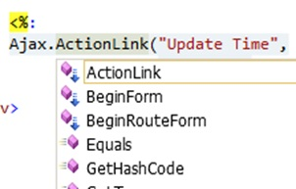

**Figure:- implement Ajax in MVC**

So if you want to create Ajax asynchronous   hyperlink by name “GetDate” which calls the “GetDate” function on the controller , below is the code for the same.  Once the controller responds this data is displayed in the HTML DIV tag by name “DateDiv”.

http://www.codeproject.com/images/minus.gifCollapse | [Copy Code](http://www.codeproject.com/Articles/556995/Model-view-controller-MVC-Interview-questions-and)

<span id="DateDiv" />

<%:

Ajax.ActionLink("Get Date","GetDate",

new AjaxOptions {UpdateTargetId = "DateDiv" })

%>

Below is the controller code. You can see how “GetDate” function has a pause of 10 seconds.

http://www.codeproject.com/images/minus.gifCollapse | [Copy Code](http://www.codeproject.com/Articles/556995/Model-view-controller-MVC-Interview-questions-and)

public class Default1Controller : Controller

{

public string GetDate()

{

Thread.Sleep(10000);

return DateTime.Now.ToString();

}

}

The second way of making Ajax call in MVC is by using Jquery. In the below code you can see we are making an ajax POST call to a URL “/MyAjax/getCustomer”. This is done by using “$.post”. All this logic is put in to a function called as “GetData” and you can make a call to the “GetData” function on a button or a hyper link click event as you want.

http://www.codeproject.com/images/minus.gifCollapse | [Copy Code](http://www.codeproject.com/Articles/556995/Model-view-controller-MVC-Interview-questions-and)

function GetData()

{

var url = "/MyAjax/getCustomer";

$.post(url, function (data)

{

$("#txtCustomerCode").val(data.CustomerCode);

$("#txtCustomerName").val(data.CustomerName);

}

)

}

**What kind of events can be tracked in AJAX?**

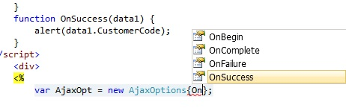

**Figure:- tracked in AJAX**

**What is the difference between “ActionResult” and “ViewResult”?**

“ActionResult” is an abstract class while “ViewResult” derives from “ActionResult” class. “ActionResult” has several derived classes like “ViewResult” ,”JsonResult” , “FileStreamResult” and so on.

“ActionResult” can be used to exploit polymorphism and dynamism. So if you are returning different types of view dynamically “ActionResult” is the best thing. For example in the below code snippet you can see we have a simple action called as “DynamicView”. Depending on the flag (“IsHtmlView”) it will either return “ViewResult” or “JsonResult”.

http://www.codeproject.com/images/minus.gifCollapse | [Copy Code](http://www.codeproject.com/Articles/556995/Model-view-controller-MVC-Interview-questions-and)

public ActionResult DynamicView()

{

if (IsHtmlView)

return View(); // returns simple ViewResult

else

return Json(); // returns JsonResult view

}

**What are the different types of results in MVC?**

http://www.codeproject.com/images/minus.gifCollapse | [Copy Code](http://www.codeproject.com/Articles/556995/Model-view-controller-MVC-Interview-questions-and)

***Note: -****It’s difficult to remember all the 12 types. But some important ones you can remember for the interview are “ActionResult”, “ViewResult” and “JsonResult”. Below is a detailed list for your interest.*

There 12 kinds of results in MVC, at the top is “ActionResult”class which is a base class that canhave11subtypes’sas listed below: -

1. ViewResult - Renders a specified view to the response stream
2. PartialViewResult - Renders a specified partial view to the response stream
3. EmptyResult - An empty response is returned
4. RedirectResult - Performs an HTTP redirection to a specified URL
5. RedirectToRouteResult - Performs an HTTP redirection to a URL that is determined by the routing engine, based on given route data
6. JsonResult - Serializes a given ViewData object to JSON format
7. JavaScriptResult - Returns a piece of JavaScript code that can be executed on the client
8. ContentResult - Writes content to the response stream without requiring a view
9. FileContentResult - Returns a file to the client
10. FileStreamResult - Returns a file to the client, which is provided by a Stream
11. FilePathResult - Returns a file to the client

**What are “ActionFilters”in MVC?**

“ActionFilters” helps you to perform logic while MVC action is executing or after a MVC action has executed.

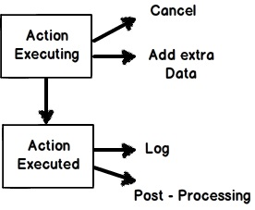

**Figure:- “ActionFilters”in MVC**

Action filters are useful in the following scenarios:-

1. Implement post-processinglogicbeforethe action happens.
2. Cancel a current execution.
3. Inspect the returned value.
4. Provide extra data to the action.

You can create action filters by two ways:-

* Inline action filter.
* Creating an “ActionFilter” attribute.

To create a inline action attribute we need to implement “IActionFilter” interface.The “IActionFilter” interface has two methods “OnActionExecuted” and “OnActionExecuting”. We can implement pre-processing logic or cancellation logic in these methods.

http://www.codeproject.com/images/minus.gifCollapse | [Copy Code](http://www.codeproject.com/Articles/556995/Model-view-controller-MVC-Interview-questions-and)

public class Default1Controller : Controller , IActionFilter

{

public ActionResult Index(Customer obj)

{

return View(obj);

}

void IActionFilter.OnActionExecuted(ActionExecutedContext filterContext)

{

Trace.WriteLine("Action Executed");

}

void IActionFilter.OnActionExecuting(ActionExecutingContext filterContext)

{

Trace.WriteLine("Action is executing");

}

}

The problem with inline action attribute is that it cannot be reused across controllers. So we can convert the inline action filter to an action filter attribute. To create an action filter attribute we need to inherit from “ActionFilterAttribute” and implement “IActionFilter” interface as shown in the below code.

http://www.codeproject.com/images/minus.gifCollapse | [Copy Code](http://www.codeproject.com/Articles/556995/Model-view-controller-MVC-Interview-questions-and)

public class MyActionAttribute : ActionFilterAttribute , IActionFilter

{

void IActionFilter.OnActionExecuted(ActionExecutedContext filterContext)

{

Trace.WriteLine("Action Executed");

}

void IActionFilter.OnActionExecuting(ActionExecutingContext filterContext)

{

Trace.WriteLine("Action executing");

}

}

Later we can decorate the controllers on which we want the action attribute to execute. You can see in the below code I have decorated the “Default1Controller” with “MyActionAttribute” class which was created in the previous code.

http://www.codeproject.com/images/minus.gifCollapse | [Copy Code](http://www.codeproject.com/Articles/556995/Model-view-controller-MVC-Interview-questions-and)

[MyActionAttribute]

public class Default1Controller : Controller

{

public ActionResult Index(Customer obj)

{

return View(obj);

}

}

**Can we create our custom view engine using MVC?**

Yes, we can create our own custom view engine in MVC. To create our own custom view engine we need to follow 3 steps:-

Let’ say we want to create a custom view engine where in the user can type a command like “<DateTime>” and it should display the current date and time.

**Step 1:-** We need to create a class which implements “IView” interface. In this class we should write the logic of how the view will be rendered in the “render” function. Below is a simple code snippet for the same.

http://www.codeproject.com/images/minus.gifCollapse | [Copy Code](http://www.codeproject.com/Articles/556995/Model-view-controller-MVC-Interview-questions-and)

public class MyCustomView : IView

{

private string _FolderPath; // Define where our views are stored

public string FolderPath

{

get { return _FolderPath; }

set { _FolderPath = value; }

}

public void Render(ViewContext viewContext, System.IO.TextWriter writer)

{

// Parsing logic <dateTime>

// read the view file

string strFileData = File.ReadAllText(_FolderPath);

// we need to and replace <datetime> datetime.now value

string strFinal = strFileData.Replace("<DateTime>", DateTime.Now.ToString());

// this replaced data has to sent for display

writer.Write(strFinal);

}

}

**Step 2 :-**We need to create a class which inherits from “VirtualPathProviderViewEngine” and in this class we need to provide the folder path and the extension of the view name. For instance for razor the extension is “cshtml” , for aspx the view extension is “.aspx” , so in the same way for our custom view we need to provide an extension. Below is how the code looks like. You can see the “ViewLocationFormats” is set to the “Views” folder and the extension is “.myview”.

http://www.codeproject.com/images/minus.gifCollapse | [Copy Code](http://www.codeproject.com/Articles/556995/Model-view-controller-MVC-Interview-questions-and)

public class MyViewEngineProvider : VirtualPathProviderViewEngine

{

// We will create the object of Mycustome view

public MyViewEngineProvider() // constructor

{

// Define the location of the View file

this.ViewLocationFormats = new string[] { "~/Views/{1}/{0}.myview", "~/Views/Shared/{0}.myview" }; //location and extension of our views

}

protected override IView CreateView(ControllerContext controllerContext, string viewPath, string masterPath)

{

var physicalpath = controllerContext.HttpContext.Server.MapPath(viewPath);

MyCustomView obj = new MyCustomView(); // Custom view engine class

obj.FolderPath = physicalpath; // set the path where the views will be stored

return obj; // returned this view paresing logic so that it can be registered in the view engine collection

}

protected override IView CreatePartialView(ControllerContext controllerContext, string partialPath)

{

var physicalpath = controllerContext.HttpContext.Server.MapPath(partialPath);

MyCustomView obj = new MyCustomView(); // Custom view engine class

obj.FolderPath = physicalpath; // set the path where the views will be stored

return obj; // returned this view paresing logic so that it can be registered in the view engine collection

}

}

**Step 3:-** We need to register the view in the custom view collection. The best place to register the custom view engine in the “ViewEngines” collection is the “global.asax” file. Below is the code snippet for the same.

http://www.codeproject.com/images/minus.gifCollapse | [Copy Code](http://www.codeproject.com/Articles/556995/Model-view-controller-MVC-Interview-questions-and)

protected void Application_Start()

{

// Step3 :- register this object in the view engine collection

ViewEngines.Engines.Add(new MyViewEngineProvider());

<span class="Apple-tab-span" style="white-space: pre; "> </span>…..

}

Below is a simple output of the custom view written using the commands defined at the top.

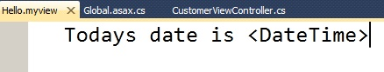

**Figure:-customviewengineusingMVC**

If you invoke this view you should see the following output.

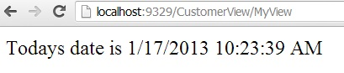

**How to send result back in JSON format in MVC?**

In MVC we have “JsonResult” class by which we can return back data in JSON format. Below is a simple sample code which returns back “Customer” object in JSON format using “JsonResult”.

http://www.codeproject.com/images/minus.gifCollapse | [Copy Code](http://www.codeproject.com/Articles/556995/Model-view-controller-MVC-Interview-questions-and)

public JsonResult getCustomer()

{

Customer obj = new Customer();

obj.CustomerCode = "1001";

obj.CustomerName = "Shiv";

return Json(obj,JsonRequestBehavior.AllowGet);

}

Below is the JSON output of the above code if you invoke the action via the browser.

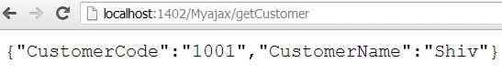

**What is “WebAPI”?**

HTTP is the most used protocol.For past many years browser was the most preferred client by which we can consume data exposed over HTTP. But as years passed by client variety started spreading out. We had demand to consume data on HTTP from clients like mobile,javascripts,windows  application etc.

For satisfying the broad range of client “REST” was the proposed approach. You can read more about “REST” from WCF chapter.

“WebAPI” is the technology by which you can expose data over HTTP following REST principles.

**But WCF SOAP also does the same thing, so how does “WebAPI” differ?**

|  |  |  |
| --- | --- | --- |
|  | **SOAP** | **WEB API** |
| **Size** | Heavy weight because of complicated WSDL structure. | Light weight, only the necessary information is transferred. |
| **Protocol** | Independent of protocols. | Only  for HTTP protocol |
| **Formats** | To parse SOAP message, the client needs to understand WSDL format. Writing custom code for parsing WSDL is a heavy duty task. If your client is smart enough to create proxy objects like how we have in .NET (add reference) then SOAP is easier to consume and call. | Output of “WebAPI” are simple string message,JSON,Simple XML format etc. So writing parsing logic for the same in very easy. |
| **Principles** | SOAP follows WS-* specification. | WEB API follows REST principles. (Please refer about REST in WCF chapter). |

**With WCF also you can implement REST,So why "WebAPI"?**

WCF was brought in to implement SOA, never the intention was to implement REST."WebAPI'" is built from scratch and the only goal is to create HTTP services using REST. Due to the one point focus for creating “REST” service “WebAPI” is more preferred.

**How to implement “WebAPI” in MVC?**

Below are the steps to implement "webAPI" :-

**Step1:-**Create the project using the "WebAPI" template.

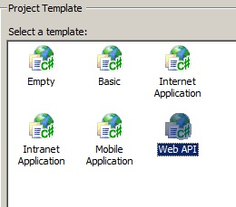

**Figure:- implement “WebAPI” in MVC**

**Step 2:-** Once you have created the project you will notice that the controller now inherits from "ApiController" and you can now implement "post","get","put" and "delete" methods of HTTP protocol.

http://www.codeproject.com/images/minus.gifCollapse | [Copy Code](http://www.codeproject.com/Articles/556995/Model-view-controller-MVC-Interview-questions-and)

public class ValuesController : ApiController

{

// GET api/values

public IEnumerable<string> Get()

{

return new string[] { "value1", "value2" };

}

// GET api/values/5

public string Get(int id)

{

return "value";

}

// POST api/values

public void Post([FromBody]string value)

{

}

// PUT api/values/5

public void Put(int id, [FromBody]string value)

{

}

// DELETE api/values/5

public void Delete(int id)

{

}

}

**Step 3:-**If you make a HTTP GET call you should get the below results.

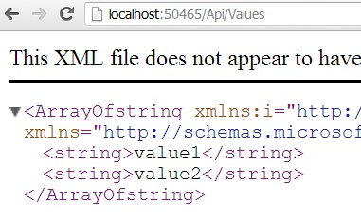

**Figure:- HTTP**

Finally do not forget to visit my video site which covers lots of [C# interview questions and answers](http://www.questpond.com/): -[www.questpond.com](http://www.questpond.com/)